RE: reviewer comments, requests are bolded. Also attached are the .rmd and .html files with relevant codes modified. They could be found on github as well. <https://github.com/billliuyc/ADA-ACCESS-Final-Project>

Also, done some code cleanup to the command to recode the variable "died" by including proper levels and labels. This means that an additional command have to be set in coxph models (as.numeric) to coerce it into a numerical variable.

**RE: For Table 1, I would suggest that you look at the characteristics in the left most column by whether they were alive or dead of breast cancer. So you will have 4 columns: 1) characteristics, 2) Overall, 3) Alive, and 4) Dead. I would also include the reporting source as a column 1 variable.**

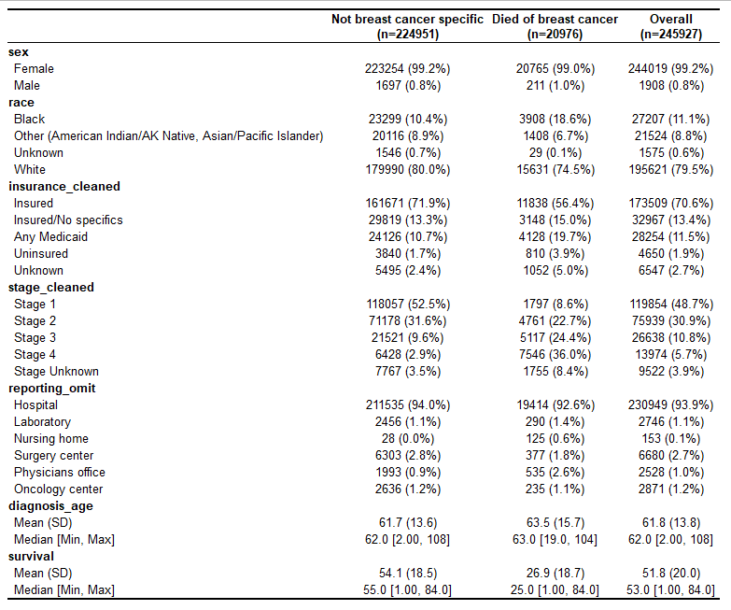

**Is there any prior literature on this topic? Typically, with respect to your main finding for nursing home residents with breast cancer?**

As discussed during the presentation, the association between nursing home residents with breast cancer and their survival is not a straightforward issue. There are multiple considerations. For one, those who are ill tend to register for nursing homes in order to receive round-the-clock care. They tend to be older, and nursing home is a typical choice for end-of-life care. Co-morbidities and old-age problems mediate the relationship between having reporting breast cancer at a nursing home and patients’ survival.

In a study on the functional status and survival of nursing home residents after breast cancer, the authors found that poorer pre-operative function is significantly associated with post-surgery mortality, as well as with post-operative functional decline.1 If we treat pre-operative function decline as an indicator or proxy of old age at nursing homes, the association found in our study is not independent. This suggest that there are unaccounted factors related to old age and nursing home that was not taken into account in our survival model. Especially in terms of end-of-life and survival, being a resident of nursing home is influenced by many associated factors. This is reinforced by literature, with authors pointing out that such functional decline can include decreased arm function due to surgery. The authors also highlighted that, poor social support for patients’ living at nursing homes are also found to be relevant in surgery survival and recovery, as well as the additional consideration of the high prevalence of cognitive impairment in the nursing home population.2

In consideration of these factors associated with living at a nursing home, it seems that this report category is different in nature from the other reporting categories. Whereas nursing home captures a long range of a patient’s life (and its associated outcomes), other categories capture a relatively short duration (i.e. one visit). This can bias the observation, artificially inflating the hazard ratios. This is something to consider with further research, suggesting determining the detailed pathway might be a good path in clarifying the relationship found in this study.

**Study population details? Who was excluded? Include diagnosis years in the information of who was included and which SEER database and age range was included.**

SEER 18 incidence data from 1975-2016 are used (Apr 15, 2019). It covers approximately 27.8% of the U.S. population based on estimates from the 2010 census. Although, according to SEER methodologies, different years of diagnosis are included for different registries in different areas. For example, Connecticut is included after 1975. Kentucky is included after 2000. However, our inclusion of the insurance recode variable limits all values to 2007+, as that is the earliest this variable is collected. SEER documentation does warn that insurance status might be modified by diagnosis age, since those who were 65+ were Medicare eligible despite labelling as uninsured, private, or unknown. However, this was not an issue in our analysis, as diagnosis age as low as 2, and as high as 108 years are adjusted and analyzed.

**Define the cancer diagnosis reporting source - give us a feel for the variable and how it was measured. This information should be available from SEER.**

The variable reporting source is identifying the source documents used to abstract the case, as described in NAACCR Item #500. As discussed during the presentation, reporting source here does not represent the first diagnosis of disease, but the most complete source. Some categories are effective after 2996, but because of our insurance variable this does not pose an issue. This might confound our analysis and prevent us from using reporting source as a proxy for patients’ access to healthcare. However, in another way, this strengthens our ability to deduce access to care, as extensive screening might not be available to everyone. Those who choose to not receive additional care past the diagnosis event, or unable to receive care, are mitigated. Also, the exclusion of autopsy and death certification categories due to the nature of survival analysis also help circumvent this problem. This reduces the generalizability of our study, but help refine its comparative power.

**How were other variables measured that were used in the analysis?**

Demographic data is collected, estimated, or produced by the U.S. Census Bureau’s Population Estimates Program, in collaboration with the National Center for Health Statistics, and with support from the NCI through an interagency agreement. Mortality data is collected and maintained by the National Center for Health Statistics. Cancer stage is derived following AJCC 7h edition guidelines, as well as incorporating ICD-10 codes. Insurance variable, as mentioned before, is derived from the NAACCR field.

**Present confidence intervals instead of p-values in the results. I would like to see a table with the HRs and CIs and reference group. If you need an example, let me know, but if you search Pubmed for SEER survival, there will be numerous examples that you can look at.**

**Table 3**: Multivariate analysis of breast-cancer survival.

|  |  |  |
| --- | --- | --- |
| Variable | Hazard Ratio (95% CI) | *p* Value |
| Reporting |  |  |
| Hospital | Reference | - |
| Laboratory | 0.98 (0.87, 1.11) | 0.785 |
| Nursing home | 7.89 (6.56, 9.48) | **<0.001** |
| Surgery center | 0.83 (0.75, 0.92) | **<0.001** |
| Physician’s office | 2.07 (1.88, 2.29) | **<0.001** |
| Oncology center | 0.91 (0.80, 1.04) | 0.152 |
| Diagnosis age | 1.02 (1.02, 1.02) | **<0.001** |
| Sex |  |  |
| Female | Reference | - |
| Male | 0.90 (0.79, 1.03) | 0.128 |
| Race |  |  |
| Black | Reference | - |
| Other (American Indian/AK Native, Asian/Pacific Islander) | 0.56 (0.53, 0.60) | **<0.001** |
| Unknown | 0.12 (0.08, 0.17) | **<0.001** |
| White | 0.66 (0.64, 0.68) | **<0.001** |
| Insurance |  |  |
| Insured | Reference | - |
| Insured/no specifics | 1.15 (1.11, 1.20) | **<0.001** |
| Any Medicaid | 1.61 (1.56, 1.67) | **<0.001** |
| Uninsured | 1.94 (1.80, 2.08) | **<0.001** |
| Unknown | 1.52 (1.41, 1.64) | **<0.001** |
| Stage of diagnosis |  |  |
| Stage 1 | Reference | - |
| Stage 2 | 4.45 (4.21, 4.70) | **<0.001** |
| Stage 3 | 14.85 (14.07, 15.68) | **<0.001** |
| Stage 4 | 65.22 (61.91, 68.71) | **<0.001** |
| Stage unknown | 12.59 (11.74, 13.50) | **<0.001** |

**Works Cited**

1. Tang V, Zhao S, Boscardin J, Sudore R, Covinsky K, Walter L C, Esserman L, Mukhtar R, Finlayson E. Functional Status and Survival After Breast Cancer Surgery in Nursing Home Residents. *JAMA Surg;* 2018;153(12):1090-1096. Doi:10.1001/jamasurg.2018.2736
2. Goodwin J S, Satish S, Anderson E T, Nattinger A B, Freeman J L. Effect of Nurse Case Management on the Treatment of Older Women with Breast Cancer. *Journal of the American Geriatrics Society;* 2003;51(9):1252-1259. Doi:10.1046/j.1532-5415.2003.51409.x